**A02: A COMPARATIVE ANALYSIS OF MACHINE LEARNING AND**

**DEEP LEARNING TOOLS AND FRAMEWORKS**

**Team Name:**

Fast Jet Learning Rockets (FJLR)

**Team Members:**

Faiza Abdullah

Jonah Joseph

Lyazzat Zilgarina

Ryan Yauch

**Professor:**

[Patricia Mcmanus](https://eagleonline.hccs.edu/courses/282423/users/264039)

**Hugging Face Transformers vs. OpenAI GPT-4 API**

### This report presents a detailed comparison between Hugging Face Transformers and OpenAI's GPT-4 API and their practical implications for AI implementation in contrast to other frameworks, supplemented by our research findings.

### ****BACKGROUND:****

### **The Hugging Face**[1] **Transformers emerged from the company's founding in 2016, developed to democratize AI by providing easy access to pre-trained models and tools. The library supports multiple deep learning frameworks including PyTorch and TensorFlow, offering thousands of pre-trained models like BERT, GPT, and T5, providing tools for training, fine-tuning, and deployment through its Model Hub.**

### **OpenAI's**[2] **GPT-4, released in 2023, is a closed-source, state-of-the-art generative model offering superior natural language understanding and generation capabilities out of the box, requiring minimal prompt engineering rather than model training.**

### https://miro.medium.com/v2/resize:fit:700/1*MgatOxId7Wx4GE3go2VBUw.png

### ****KEY FEATURES:****

### **HFT offers pipeline abstractions for easy model deployment, extensive documentation and community support, and integration with popular deep learning frameworks. The library excels in customization and fine-tuning capabilities, allowing developers to adapt models for specific use cases.**

### 

### **Whereas GPT-4 is accessible only through APIs with a closed architecture but it provides consistent high performance across tasks, regular model updates, and robust API infrastructure. The API-first approach simplifies integration but limits customization compared to Hugging Face.**

### ****WORK-FLOWS:****

### ****HFT:****

### 

### ****GPT4 API:****

### 

### ****KEY INSIGHTS:****

### 

### ****REAL-WORLD APPLICATIONS:****

Google uses Hugging Face models for NLP tasks and integrates them into Google Cloud services.[3] Microsoft leverages Hugging Face models in the Azure Machine Learning platform to offer pre-trained language models. Meta engages with Hugging Face in various AI and NLP-related research, especially in implementing transformer models for large-scale language applications.**[4]** Amazon uses Hugging Face for fine-tuning models in product recommendation systems via Amazon SageMaker. **Kustomer, an omnichannel SaaS CRM platform, is an outstanding example of Hugging Face & AWS collaboration.[5]**

### **GPT-4 deepens the conversation on Duolingo through Role Play and Explain my Answer features in Duolingo Max.**[6] **Khan Academy utilizes GPT-4 to power Khanmigo, an AI-powered virtual tutor for students and a classroom assistant for teachers.**[7]GitHub upgraded the Copilot Chat experience by integrating OpenAI's GPT-4 model, enhancing the accuracy and usefulness of code suggestions.[8]

### ****COMPARATIVE PERSPECTIVE:****

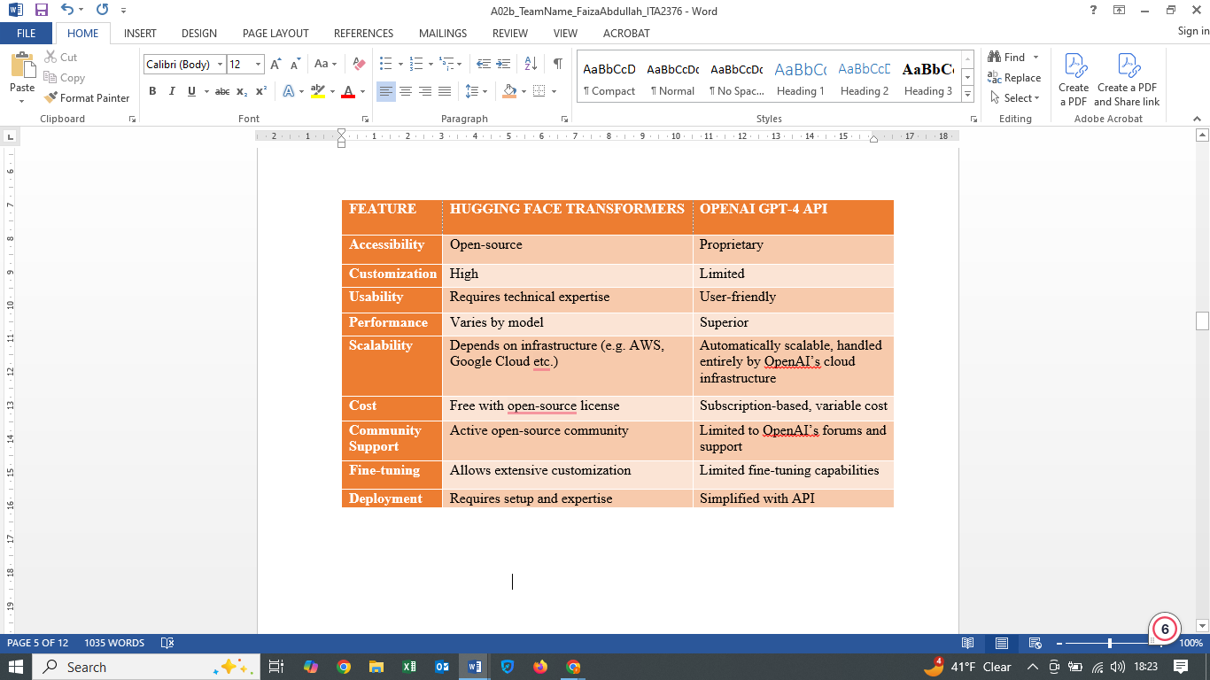

### ****CODE EXAMPLE:****

### ****HFT****[9]****:****

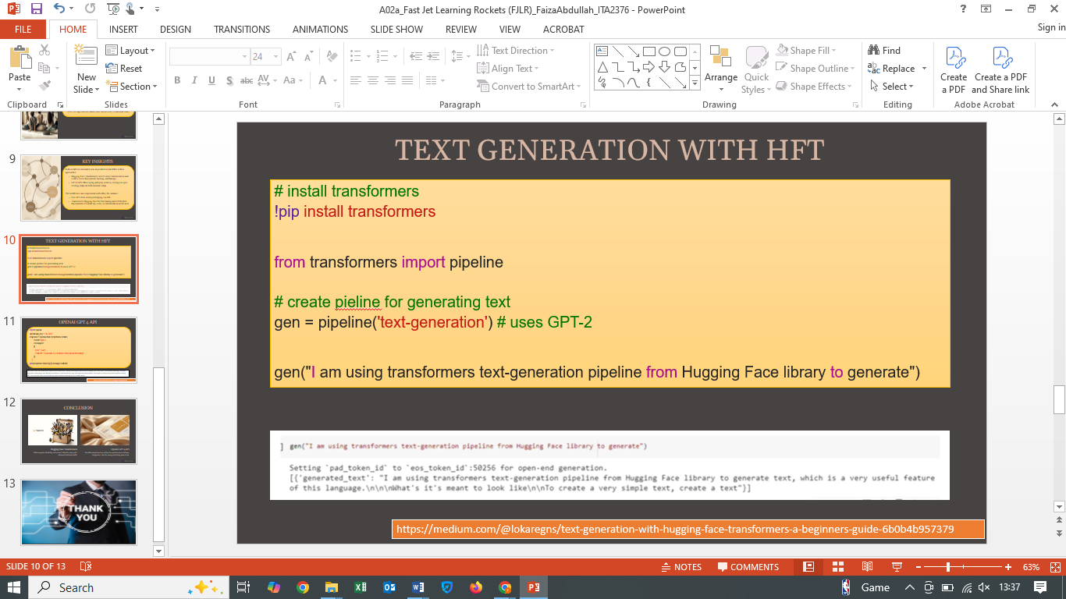

### ****OPENAI GPT4 API****[10]****:****

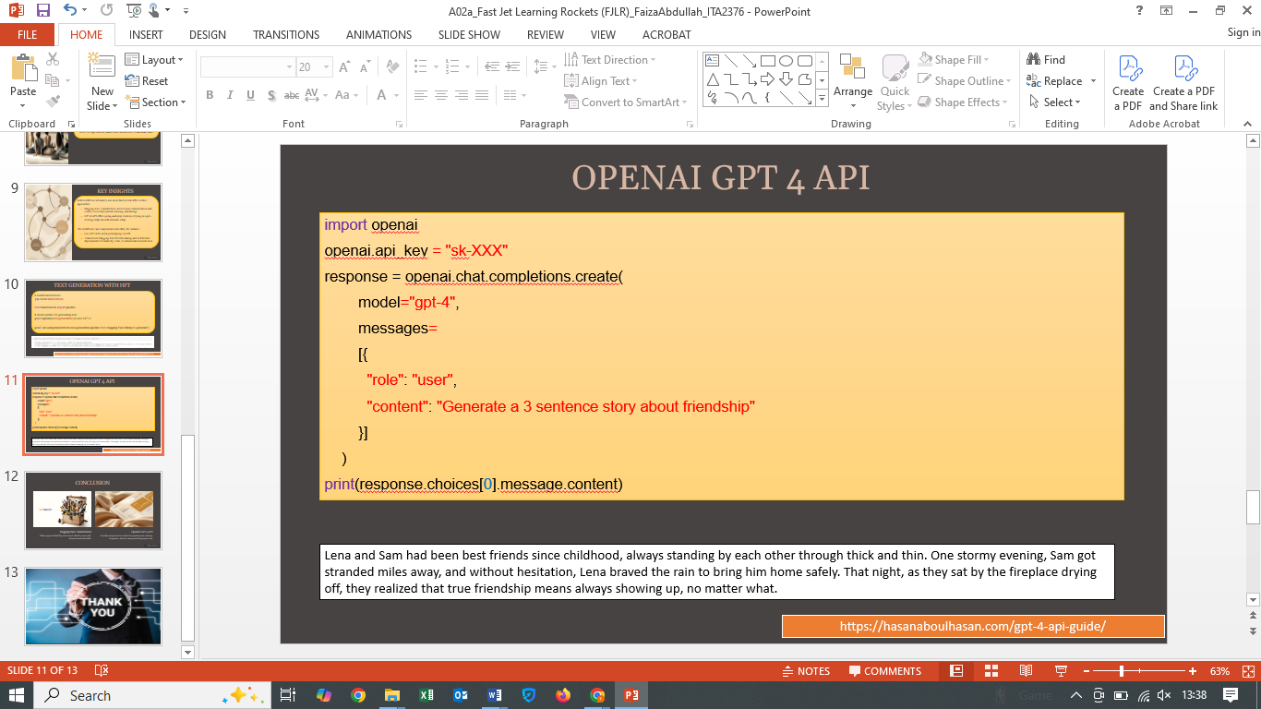

### ****REFLECTION ON UNFAMILIAR CONCEPTS:****

### Attention Mechanisms: Allow models to focus on different parts of input data with varying importance weights, crucial for appreciating the architectural differences between frameworks.[11]

### Fine-tuning in NLP: Adapting a pre-trained model to a specific task by training it further on a tailored dataset, which allows models to achieve higher accuracy for domain-specific tasks.[12]

**CONCLUSION:**

### This research has provided valuable insights into the strengths and limitations of both platforms. Hugging Face Transformers offers greater flexibility and control but requires more technical expertise, hence is ideal for developers seeking customization and open-source collaboration while GPT-4 API provides superior out-of-box performance with simpler implementation but less customization ability, making it a user-friendly API suited for businesses prioritizing ease of deployment and advanced performance.

### ****CITATIONS:****

### <https://huggingface.co/>

### <https://odsc.medium.com/the-evolution-of-hugging-face-and-its-role-in-democratizing-ai-76f19af6d374>

### <https://www.forbes.com/sites/kenrickcai/2022/05/09/the-2-billion-emoji-hugging-face-wants-to-be-launchpad-for-a-machine-learning-revolution/>

### <https://medium.com/nerd-for-tech/all-you-need-to-know-comprehensive-faq-on-hugging-face-transformers-93b9268f59fa>

### <https://openai.com/index/gpt-4-research/>

### <https://www.reddit.com/r/OpenAI/?rdt=39323>

### <https://toxigon.com/advances-in-natural-language-processing-2025>

### <https://www.pluggai.com/overview-of-hugging-face-ai-models-and-their-real-world-applications>

### ****SUPPLEMENTARY RESOURCES:****

**Official Documentation:**

* Hugging Face: <https://huggingface.co/docs/transformers>
* OpenAI GPT-4: <https://platform.openai.com/docs>

**Scholarly Articles/ Tech Blogs:**

1. Performance Analysis of Transformer Based Models (BERT, ALBERT and RoBERTa) (<https://arxiv.org/pdf/2308.04950>)
2. The study “Navigating Dataset Documentations in AI: A Large-Scale Analysis of Dataset Cards on Hugging Face” analyzes 7,433 dataset documentations on Hugging Face for dataset documentation practices (<https://arxiv.org/html/2401.13822v1>)
3. Blogs: <https://huggingface.co/blog>
4. Hugging Face vs. OpenAI (<https://chrisyandata.medium.com/hugging-face-vs-openai-a-comprehensive-comparison-for-genai-models-d118feed34a5>)
5. CHAT GPT-4 technical report - <https://cdn.openai.com/papers/gpt-4.pdf>

**User Reviews:**

1. Hugging Face Forum: [https://discuss.huggingface.co](https://discuss.huggingface.co/)
2. OpenAI Community: <https://community.openai.com/>

### Additional Materials

* Code snippets: <https://github.com/huggingface/transformers>, <https://github.com/openai/openai-cookbook>, https://huggingface.co/learn/nlp-course/chapter1/1
* GPT-4o API Tutorial: <https://www.datacamp.com/tutorial/gpt4o-api-openai-tutorial>

### ****STATEMENT OF PARTICIPATION:****

Faiza Abdullah & Lyazzat Zilgarina worked side by side on both report & presentation except final compilation, editing, adding tables / images / code was done by Faiza, however it would not have been possible without due support from Lyazzat.

***Did not participate:***

Jonah Joseph

Ryan Yauch

**Learning Outcomes:**

1. Insights into transformer architecture and attention mechanisms
2. Improved ability to evaluate AI platforms for specific use cases
3. Better appreciation of the trade-offs involved in AI system design
4. Insights into the trade-offs between open-source and proprietary AI tools.
5. Explored real-world applications and scalability considerations.

1. <https://huggingface.co/>
2. <https://openai.com/>
3. <https://huggingface.co/blog/gcp-partnership>
4. <http://originality.ai/blog/huggingface-statistics>
5. <https://huggingface.co/case-studies/aws/kustomer>
6. <https://openai.com/index/duolingo/>
7. <https://openai.com/index/khan-academy/>
8. <https://github.blog/changelog/2023-11-30-github-copilot-november-30th-update/>
9. ### <https://medium.com/@lokaregns/text-generation-with-hugging-face-transformers-a-beginners-guide-6b0b4b957379>

  
10. ### https://hasanaboulhasan.medium.com/gpt-4-api-guide-with-examples-all-scripts-included-afa1b6a5c3d9

   
11. https://medium.com/@zhonghong9998/attention-mechanisms-in-deep-learning-enhancing-model-performance-32a91006092a
12. <https://huggingface.co/docs/transformers/training>